

Detailed Design Document
By
P2G2

Version: | 1
Last Update Date: | 27/11/2014
Author: | Sreerag S
Owner: | Tata Consultancy Services
Reviewer:

Document History

Version | Date | Description | Author
1 | 21/11/2014 | The preliminary design | Sreerag S
2 | 27/11/2014 | Slight modifications

Table of Contents
1.1 Objective 4
5.1 Source to Stage: 5
5.2 Stage to Target 6
5.3 Tools 6
6.1 Source to Stage: 7
6.1.1 Mapping1 7
6.1.2 Mapping2 8
6.1.3 Mapping3 9
6.1.4 Mapping4 9
6.1.5 Mapping5 10
6.1.6 Mapping6 11
6.1.7 Mapping7 12
6.1.8 Mapping8 13
6.1.9 Mapping9 14
6.1.10 Mapping10 15
6.1.11 Mapping11 16
6.1.12 Mapping12 17
6.2 Stage to Target 18
6.2.1 Mapping1 18
6.2.2 Mapping2 19
6.2.3 Mapping3 20
6.2.4 Mapping4 21
6.2.5 Mapping5 22
6.3 Job sequence 23

Introduction

Indian Teleservices Limited(ITL) is a telecom service provider in India.It is a newly launched company and has 8 outlets spread across 3 states – Maharashtra,Karnataka and West Bengal.
Currently Indian Teleservices has a market share of only 5% in India. ITL has a vision of achieving 50% market share in Indian cellular market in the next 5 years. ITL has approached TCS to help them design and build a new BI application which will help them to analyze their current performance and come up with strategies to improve the business.
The initial requirement from ITL is to build a Data mart for the following operational areas and create analytical reports out of it. The operational data from Karnataka and Maharashtra will be available in a relational database, and data from West Bengal will be made available in files.

Objective

To design and implement a data mart for usage and billing business process to evaluate the company's performance in different perspectives.

Requirements

High level technical requirements for this project are
- Database (Oracle 11g)
- ETL tool (Informatica power center v9.1)
- Reporting tool (Business Objects)

Dependencies and Assumptions

Describe the dependencies
- The source tables and data should be available.
- The target tables in the staging area has to be created.
- The fact and dimensional tables has to be created.
- All the required tools like database,ETL tool,reporting tool has to be made available.

Impact Analysis

Mention the existing systems that are impacted due to this development and the solution.

High Level Design

Source to Stage:

Source
Stage

ITL_BRANCH
TBI74_P2G2_BRANCH_STG_DB
ITL_CITY
TBI74_P2G2_CITY_STG_DB
ITL_SIM
TBI74_P2G2_SIM_STG_DB
ITL_SIM
TBI74_P2G2_SIM_STG_FF
ITL_RATE_PLAN
TBI74_P2G2_RATEPLAN_STG_DB
ITL_RATE_PLAN
TBI74_P2G2_RATEPLAN_STG_FF
ITL_RATE_PLAN_CHARGE
TBI74_P2G2_RATE_PLAN_CHARGE_STG_DB
ITL_RATE_PLAN_CHARGE
TBI74_P2G2_RATE_PLAN_CHARGE_STG_FF
ITL_CDR
TBI74_P2G2_CDR_STG_DB
ITL_CDR
TBI74_P2G2_CDR_STG_FF
ITL_SERVICE_TYPE
TBI74_P2G2_SERVICETYPE_STG_DB
DATE_DIM
TBI74_P2G2_DATE_STG_DB

Stage to Target

Source
Target
Transformations
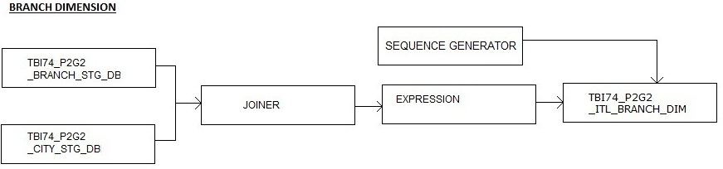

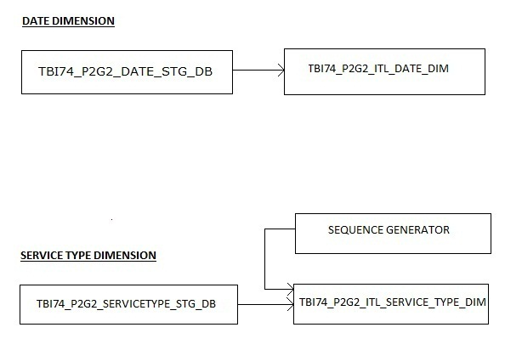

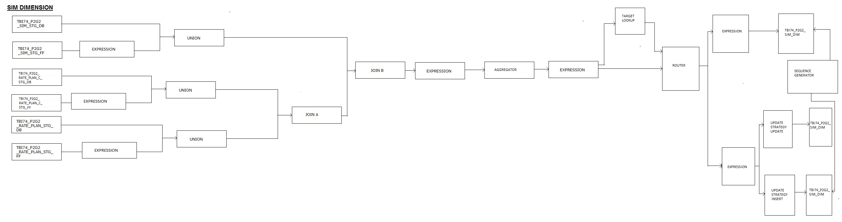
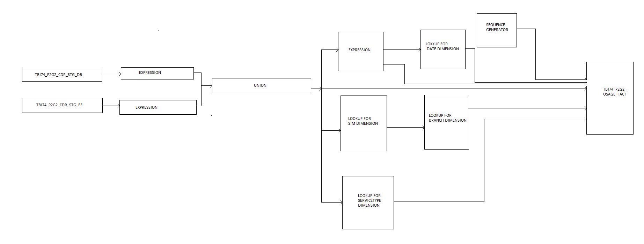

Tools
Subject Area | Tools
Databases : | Oracle 11g
ETL : | Informatica PowerCenter v9.1.0
Metadata Management :
Version Control :

Low Level Design

Source to Stage:

Mapping1

Mapping Name : | M_TBI74_P2G2_RATEPLAN_STG_FF
Mapping Description: | Direct loading of staging area table with rate plan details from flat file
Session Name : | S_M_TBI74_P2G2_RATEPLAN_STG_FF
Workflow Name : | WF_S_M_TBI74_P2G2_RATEPLAN_STG_FF
Preprocessing requirement : | The target tables has to be created with correct datatyes as per requirements.
Post processing requirement : | Make sure the stage table is loaded with the required data
Extraction Frequency : | Monthly
Time window : | 12 hrs (9 pm to 9 am)
Exception Handling:

Source Tables
Table name : | Database/Flat file | Connection Information/file path for flat file
ITL_RATE_PLAN | Flat file | \\intvmstg1\ILP Home\BIPM\TBI-74\P2G2\10 Miscellaneous\Source Files -ITLFileData

Target Tables
Table name : | Database/Flat file | Connection Information/file path for flat file | Load Strategy
TBI74_P2G2_RATEPLAN_STG_FF | orainfodb | Username(STG_15q2) password(ilptcs) | Direct

Mapping Specification
\\intvmstg1\ILP Home\BIPM\TBI-74\P2G2\04 Design\ETL Mapping Specification Document v1.0\ M_TBI74_P2G2_RATEPLAN_STG_FF

Mapping2

Mapping Name : | M_TBI74_P2G2_BRANCH_STG_DB
Mapping Description: | Direct loading of staging area table with branch details from database
Session Name : | S_M_TBI74_P2G2_BRANCH_STG_DB
Workflow Name : | WF_S_M_TBI74_P2G2_BRANCH_STG_DB
Preprocessing requirement : | The target tables has to be created with correct datatyes as per requirements.
Post processing requirement : | Make sure the stage table is loaded with the required data
Extraction Frequency : | Monthly
Time window : | 12 hrs (9 pm to 9 am)
Exception Handling :

Source Tables
Table name : | Database/Flat file | Connection Information/file path for flat file
ITL_BRANCH | orainfodb | Username(info_trainee) password(ilptcs)

Target Tables
Table name : | Database/Flat file | Connection Information/file path for flat file | Load Strategy
TBI74_P2G2_BRANCH_STG_DB | orainfodb | Username(STG_15q2) password(ilptcs) | Direct

Mapping Specification
\\intvmstg1\ILP Home\BIPM\TBI-74\P2G2\04 Design\ETL Mapping Specification Document v1.0\ M_TBI74_P2G2_BRANCH_STG_DB

Mapping3

Mapping Name : | M_TBI74_P2G2_CITY_STG_DB
Mapping Description: | Direct loading of staging area table with city details from database
Session Name : | S_M_M_TBI74_P2G2_CITY_STG_DB
Workflow Name : | WF_S_M_M_TBI74_P2G2_CITY_STG_DB
Preprocessing requirement : | The target tables has to be created with correct datatyes as per requirements.
Post processing requirement : | Make sure the stage table is loaded with the required data
Extraction Frequency : | Monthly
Time window : | 12 hrs (9 pm to 9 am)
Exception Handling :

Source Tables
Table name : | Database/Flat file | Connection Information/file path for flat file
ITL_CITY | orainfodb | Username(info_trainee) password(ilptcs)

Target Tables
Table name : | Database/Flat file | Connection Information/file path for flat file | Load Strategy
TBI74_P2G2_CITY_STG_DB | orainfodb | Username(STG_15q2) password(ilptcs) | Direct

Mapping Specification
\\intvmstg1\ILP Home\BIPM\TBI-74\P2G2\04 Design\ETL Mapping Specification Document v1.0\ M_TBI74_P2G2_CITY_STG_DB

Mapping4

Mapping Name : | M_TBI74_P2G2_SIM_STG_DB
Mapping Description: | Direct loading of staging area table with sim details from database
Session Name : | S_M_TBI74_P2G2_SIM_STG_DB
Workflow Name : | WF_S_M_TBI74_P2G2_SIM_STG_DB
Preprocessing requirement : | The target tables has to be created with correct datatyes as per requirements.
Post processing requirement : | Make sure the stage table is loaded with the required data
Extraction Frequency : | Monthly
Time window : | 12 hrs (9 pm to 9 am)
Exception Handling :

Source Tables
Table name : | Database/Flat file | Connection Information/file path for flat file
ITL_SIM | orainfodb | Username(info_trainee) password(ilptcs)

Target Tables
Table name : | Database/Flat file | Connection Information/file path for flat file | Load Strategy
TBI74_P2G2_SIM_STG_DB | orainfodb | Username(STG_15q2) password(ilptcs) | DIRECT

Mapping Specification
\\intvmstg1\ILP Home\BIPM\TBI-74\P2G2\04 Design\ETL Mapping Specification Document v1.0 \M_TBI74_P2G2_SIM_STG_DB

Mapping5

Mapping Name : | M_TBI74_P2G2_SIM_STG_FF
Mapping Description: | Direct loading of staging area table with sim details from flat file.
Session Name : | S_M_TBI74_P2G2_SIM_STG_FF
Workflow Name : | WF_S_M_TBI74_P2G2_SIM_STG_FF
Preprocessing requirement : | The target tables has to be created with correct datatyes as per requirements.
Post processing requirement : | Make sure the stage table is loaded with the required data
Extraction Frequency : | Monthly
Time window : | 12 hrs (9 pm to 9 am)
Exception Handling :

Source Tables
Table name : | Database/Flat file | Connection Information/file path for flat file
ITL_SIM | Flat file | \\intvmstg1\ILP Home\BIPM\TBI-74\P2G2\10 Miscellaneous\Source Files -ITLFileData

Target Tables
Table name : | Database/Flat file | Connection Information/file path for flat file | Load Strategy
TBI74_P2G2_SIM_STG_FF | orainfodb | Username(STG_15q2) password(ilptcs) | Direct

Mapping Specification
\\intvmstg1\ILP Home\BIPM\TBI-74\P2G2\04 Design\ETL Mapping Specification Document v1.0\ M_TBI74_P2G2_SIM_STG_FF

Mapping6

Mapping Name : | M_TBI74_P2G2_RATEPLAN_STG_DB
Mapping Description: | Direct loading of staging area table with rate plan details from database.
Session Name : | S_M_TBI74_P2G2_RATEPLAN_STG_DB
Workflow Name : | WF_S_M_TBI74_P2G2_RATEPLAN_STG_DB
Preprocessing requirement : | The target tables has to be created with correct datatyes as per requirements.
Post processing requirement : | Make sure the stage table is loaded with the required data
Extraction Frequency : | Monthly
Time window : | 12 hrs (9 pm to 9 am)
Exception Handling :

Source Tables
Table name : | Database/Flat file | Connection Information/file path for flat file
ITL_RATE_PLAN | orainfodb | Username(WRK_15q2) password(ilptcs)

Target Tables
Table name : | Database/Flat file | Connection Information/file path for flat file | Load Strategy
TBI74_P2G2_RATE_PLAN_C_STG_DB | orainfodb | Username(STG_15q2) password(ilptcs) | Direct

Mapping Specification
\\intvmstg1\ILP Home\BIPM\TBI-74\P2G2\04 Design\ETL Mapping Specification Document v1.0 \M_TBI74_P2G2_RATEPLAN_STG_DB

Mapping7

Mapping Name : | M_TBI74_P2G2_RATE_PLAN_C_STG_FF
Mapping Description: | Direct loading of staging area table with rate plan charge details from flat file.
Session Name : | S_M_TBI74_P2G2_RATE_PLAN_C_STG_FF
Workflow Name : | WF_S_M_TBI74_P2G2_RATE_PLAN_C_STG_FF
Preprocessing requirement : | The target tables has to be created with correct datatyes as per requirements.
Post processing requirement : | Make sure the stage table is loaded with the required data
Extraction Frequency : | Monthly
Time window : | 12 hrs (9 pm to 9 am)
Exception Handling :

Source Tables
Table name : | Database/Flat file | Connection Information/file path for flat file
ITL_RATE_PLAN_CHARGE | Flat file | \\intvmstg1\ILP Home\BIPM\TBI-74\P2G2\10 Miscellaneous\Source Files -ITLFileData

Target Tables
Table name : | Database/Flat file | Connection Information/file path for flat file | Load Strategy
TBI74_P2G2_RATE_PLAN_C_STG_FF | orainfodb | Username(STG_15q2) password(ilptcs) | direct

Mapping Specification
\\intvmstg1\ILP Home\BIPM\TBI-74\P2G2\04 Design\ETL Mapping Specification Document v1.0\ M_TBI74_P2G2_RATE_PLAN_C_STG_FF

Mapping8

Mapping Name : | M_TBI74_P2G2_CDR_STG_DB
Mapping Description: | Direct loading of staging area table with call duration record details from database.
Session Name : | S_M_TBI74_P2G2_CDR_STG_DB
Workflow Name : | WF_S_M_TBI74_P2G2_CDR_STG_DB
Preprocessing requirement : | The target tables has to be created with correct datatyes as per requirements.
Post processing requirement : | Make sure the stage table is loaded with the required data
Extraction Frequency : | Monthly
Time window : | 12 hrs (9 pm to 9 am)
Exception Handling :

Source Tables
Table name : | Database/Flat file | Connection Information/file path for flat file
ITL_CDR | orainfodb | Username(WRK_15q2) password(ilptcs)

Target Tables
Table name : | Database/Flat file | Connection Information/file path for flat file | Load Strategy
TBI74_P2G2_CDR_STG_DB | orainfodb | Username(STG_15q2) password(ilptcs) | Direct

Mapping Specification
\\intvmstg1\ILP Home\BIPM\TBI-74\P2G2\04 Design\ETL Mapping Specification Document v1.0\M_TBI74_P2G2_CDR_STG_DB

Mapping9

Mapping Name : | M_TBI74_P2G2_CDR_STG_FF
Mapping Description: | Direct loading of staging area table with cal duration register details from flat file.
Session Name : | S_M_TBI74_P2G2_CDR_STG_FF
Workflow Name : | WF_S_M_TBI74_P2G2_CDR_STG_FF
Preprocessing requirement : | The target tables has to be created with correct datatyes as per requirements.
Post processing requirement : | Make sure the stage table is loaded with the required data
Extraction Frequency : | Monthly
Time window : | 12 hrs (9 pm to 9 am)
Exception Handling :

Source Tables
Table name : | Database/Flat file | Connection Information/file path for flat file
ITL_CDR | Flat file | \\intvmstg1\ILP Home\BIPM\TBI-74\P2G2\10 Miscellaneous\Source Files -ITLFileData

Target Tables
Table name : | Database/Flat file | Connection Information/file path for flat file | Load Strategy
TBI74_P2G2_CDR_STG_FF | orainfodb | Username(STG_15q2) password(ilptcs) | Direct

Mapping Specification
\\intvmstg1\ILP Home\BIPM\TBI-74\P2G2\04 Design\ETL Mapping Specification Document v1.0\ M_TBI74_P2G2_CDR_STG_FF

Mapping10

Mapping Name : | M_TBI74_P2G2_SERVICETYPE_STG_DB
Mapping Description: | Direct loading of staging area table with service type details from database.
Session Name : | S_M_TBI74_P2G2_SERVICETYPE_STG_DB
Workflow Name : | WF_S_M_TBI74_P2G2_SERVICETYPE_STG_DB
Preprocessing requirement : | The target tables has to be created with correct datatyes as per requirements.
Post processing requirement : | Make sure the stage table is loaded with the required data
Extraction Frequency : | Monthly
Time window : | 12 hrs (9 pm to 9 am)
Exception Handling :

Source Tables
Table name : | Database/Flat file | Connection Information/file path for flat file
ITL_SERVICE_TYPE | orainfodb | Username(WRK_15q2) password(ilptcs)

Target Tables
Table name : | Database/Flat file | Connection Information/file path for flat file | Load Strategy
TBI74_P2G2_SERVICETYPE_STG_DB | orainfodb | Username(STG_15q2) password(ilptcs) | Direct

Mapping Specification
\\intvmstg1\ILP Home\BIPM\TBI-74\P2G2\04 Design\ETL Mapping Specification Document v1.0\ M_TBI74_P2G2_SERVICETYPE_STG_DB

Mapping11

Mapping Name : | M_TBI74_P2G2_DATE_STG_DB
Mapping Description: | Direct loading of staging area table with date details from database.
Session Name : | S_M_TBI74_P2G2_DATE_STG_DB
Workflow Name : | WF_S_M_TBI74_P2G2_DATE_STG_DB
Preprocessing requirement : | The target tables has to be created with correct datatyes as per requirements.
Post processing requirement : | Make sure the stage table is loaded with the required data
Extraction Frequency : | Monthly
Time window : | 12 hrs (9 pm to 9 am)
Exception Handling :

Source Tables
Table name : | Database/Flat file | Connection Information/file path for flat file
DATE_DIM | orainfodb | Username(WRK_15q2) password(ilptcs)

Target Tables
Table name : | Database/Flat file | Connection Information/file path for flat file | Load Strategy
TBI74_P2G2_DATE_STG_DB | orainfodb | Username(STG_15q2) password(ilptcs) | Direct

Mapping Specification
\\intvmstg1\ILP Home\BIPM\TBI-74\P2G2\04 Design\ETL Mapping Specification Document v1.0 \M_TBI74_P2G2_DATE_STG_DB

Mapping12

Mapping Name : | M_TBI74_P2G2_RATE_PLAN_C_STG_DB
Mapping Description: | Direct loading of staging area table with rate plan charge details from database.
Session Name : | S_M_TBI74_P2G2_RATE_PLAN_C_STG_DB
Workflow Name : | WF_S_M_TBI74_P2G2_RATE_PLAN_C_STG_DB
Preprocessing requirement : | The target tables has to be created with correct datatyes as per requirements.
Post processing requirement : | Make sure the stage table is loaded with the required data
Extraction Frequency : | Monthly
Time window : | 12 hrs (9 pm to 9 am)
Exception Handling :

Source Tables
Table name : | Database/Flat file | Connection Information/file path for flat file
ITL_RATE_PLAN_CHARGE_PLAN | orainfodb | Username(WRK_15q2) password(ilptcs)

Target Tables
Table name : | Database/Flat file | Connection Information/file path for flat file | Load Strategy
TBI74_P2G2_RATE_PLAN_C_STG_DB | orainfodb | Username(STG_15q2) password(ilptcs) | Direct

Mapping Specification
\\intvmstg1\ILP Home\BIPM\TBI-74\P2G2\04 Design\ETL Mapping Specification Document v1.0\ M_TBI74_P2G2_RATE_PLAN_C_STG_DB

Stage to Target

Mapping1

Mapping Name : | M_TBI74_P2G2_ITL_BRANCH_DIM
Mapping Description: | Loading of branch dimension after performing some transformations on stage tables
Session Name : | S_M_TBI74_P2G2_ITL_BRANCH_DIM
Workflow Name : | WF_S_M_TBI74_P2G2_ITL_BRANCH_DIM
Preprocessing requirement : | The required dimension structure has to be created with correct fields and datatypes.
Post processing requirement : | Make sure the dimension table is loaded with the required data.
Extraction Frequency : | Monthly
Time window : | Anytime
Exception Handling :

Source Tables
Table name : | Database/Flat file | Connection Information/file path for flat file
TBI74_P2G2_BRANCH_STG_DB | orainfodb | Username(STG_15q2) password(ilptcs)
TBI74_P2G2_CITY_STG_DB | orainfodb | Username(STG_15q2) password(ilptcs)

Target Tables
Table name : | Database/Flat file | Connection Information/file path for flat file | Load Strategy
TBI74_P2G2_ITL_BRANCH_DIM | orainfodb | Username(EDW_15q2) password(ilptcs) | Indirect

Mapping Specification
\\intvmstg1\ILP Home\BIPM\TBI-74\P2G2\04 Design\ETL Mapping Specification Document v1.0\ M_TBI74_P2G2_ITL_BRANCH_DIM

Mapping2

Mapping Name : | M_TBI74_P2G2_ITL_DATE_DIM
Mapping Description: | Loading of date dimension after performing some transformations on stage tables
Session Name : | S_M_TBI74_P2G2_ITL_DATE_DIM
Workflow Name : | WF_S_M_TBI74_P2G2_ITL_DATE_DIM
Preprocessing requirement : | The required dimension structure has to be created with correct fields and datatypes.
Post processing requirement : | Make sure the dimension table is loaded with the required data.
Extraction Frequency : | Monthly
Time window : | Anytime
Exception Handling :

Source Tables
Table name : | Database/Flat file | Connection Information/file path for flat file
TBI74_P2G2_DATE_STG_DB | orainfodb | Username(STG_15q2) password(ilptcs)

Target Tables
Table name : | Database/Flat file | Connection Information/file path for flat file | Load Strategy
TBI74_P2G2_ITL_DATE_DIM | orainfodb | Username(EDW_15q2) password(ilptcs) | Indirect

Mapping Specification
\\intvmstg1\ILP Home\BIPM\TBI-74\P2G2\04 Design\ETL Mapping Specification Document v1.0\ M_TBI74_P2G2_ITL_DATE_DIM

Mapping3

Mapping Name : | M_TBI74_P2G2_ITL_SERVICE_TYPE_DIM
Mapping Description: | Loading of service type dimension after performing some transformations on stage tables
Session Name : | S_M_TBI74_P2G2_ITL_SERVICE_TYPE_DIM
Workflow Name : | WF_M_TBI74_P2G2_ITL_SERVICE_TYPE_DIM
Preprocessing requirement : | The required dimension structure has to be created with correct fields and datatypes.
Post processing requirement : | Make sure the dimension table is loaded with the required data.
Extraction Frequency : | Monthly
Time window : | Anytime
Exception Handling :

Source Tables
Table name : | Database/Flat file | Connection Information/file path for flat file
TBI74_P2G2_SERVICETYPE_STG_DB | orainfodb | Username(STG_15q2) password(ilptcs)

Target Tables
Table name : | Database/Flat file | Connection Information/file path for flat file | Load Strategy
TBI74_P2G2_ITL_SERVICE_TYPE_DIM | orainfodb | Username(EDW_15q2) password(ilptcs) | Indirect

Mapping Specification
\\intvmstg1\ILP Home\BIPM\TBI-74\P2G2\04 Design\ETL Mapping Specification Document v1.0\ M_TBI74_P2G2_ITL_SERVICE_TYPE_DIM

Mapping4

Mapping Name : | M_TBI74_P2G2_ITL_SIM_DIM
Mapping Description: | Loading of sim dimension after performing some transformations on stage tables
Session Name : | S_M_TBI74_P2G2_ITL_SIM_DIM
Workflow Name : | WF_S_M_TBI74_P2G2_ITL_SIM_DIM
Preprocessing requirement : | The required dimension structure has to be created with correct fields and datatypes.
Post processing requirement : | Make sure the dimension table is loaded with the required data.
Extraction Frequency : | Monthly
Time window : | Anytime
Exception Handling :

Source Tables
Table name : | Database/Flat file | Connection Information/file path for flat file
TBI74_P2G2_SIM_STG_DB | orainfodb | Username(STG_15q2) password(ilptcs)
TBI74_P2G2_SIM_STG_FF | Flat file | \\intvmstg1\ILP Home\BIPM\TBI-74\P2G2\10 Miscellaneous\Source Files -ITLFileData
TBI74_P2G2_RATE_PLAN_C_STG_DB | orainfodb | Username(STG_15q2) password(ilptcs)
TBI74_P2G2_RATE_PLAN_C_STG_FF | Flat file | \\intvmstg1\ILP Home\BIPM\TBI-74\P2G2\10 Miscellaneous\Source Files -ITLFileData
TBI74_P2G2_RATE_PLAN_STG_DB | orainfodb | Username(STG_15q2) password(ilptcs)
TBI74_P2G2_RATE_PLAN_STG_FF | Flat file | \\intvmstg1\ILP Home\BIPM\TBI-74\P2G2\10 Miscellaneous\Source Files -ITLFileData

Target Tables
Table name : | Database/Flat file | Connection Information/file path for flat file | Table name :
TBI74_P2G2_ITL_SIM_DIM | orainfodb | Username(EDW_15q2) password(ilptcs) | Indirect

Mapping Specification
\\intvmstg1\ILP Home\BIPM\TBI-74\P2G2\04 Design\ETL Mapping Specification Document v1.0\ M_TBI74_P2G2_ITL_SIM_DIM

Mapping5

Mapping Name : | M_TBI74_P2G2_ITL_USAGE_FACT
Mapping Description: | Loading of fact table referencing dimension tables and some measure.
Session Name : | S_M_TBI74_P2G2_ITL_USAGE_FACT
Workflow Name : | WF_S_M_TBI74_P2G2_ITL_USAGE_FACT
Preprocessing requirement : | The required dimension structure has to be created with correct fields and datatypes.
Post processing requirement : | Make sure the dimension table is loaded with the required data.
Extraction Frequency : | Monthly
Time window : | Anytime
Exception Handling :

Source Tables
Table name : | Database/Flat file | Connection Information/file path for flat file
TBI74_P1G2_ITL_SIM_DIM | orainfodb | Username(STG_15q2) password(ilptcs)
TBI74_P1G2_ITL_CDR_STG_DB | orainfodb | Username(STG_15q2) password(ilptcs)
TBI74_P1G2_ITL_CDR_STG_FF | Flat file | \intvmstg1\ILP Home\BIPM\TBI-74\P2G2\10 Miscellaneous\Source Files -ITLFileData
TBI74_P1G2_IT_RATE_PLAN_CHARGE_STG_FF | Flat file | \intvmstg1\ILP Home\BIPM\TBI-74\P2G2\10 Miscellaneous\Source Files -ITLFileData
TBI74_P1G2_IT_RATE_PLAN_CHARGE_STG_DB | orainfodb | Username(STG_15q2) password(ilptcs)
TBI74_P2G2_ITL_BRANCH_DIM | orainfodb | Username(STG_15q2) password(ilptcs)
TBI74_P2G2_ITL_DATE_DIM | orainfodb | Username(STG_15q2) password(ilptcs)
TBI74_P2G2_ITL_SERVICE_TYPE_DIM | orainfodb | Username(STG_15q2) password(ilptcs)

Target Tables
Table name : | Database/Flat file | Connection Information/file path for flat file | Load Strategy
TBI74_P2G2_ITL_USAGE_FACT | orainfodb | Username(EDW_15q2) password(ilptcs) | Indirect

Mapping Specification
\\intvmstg1\ILP Home\BIPM\TBI-74\P2G2\04 Design\ETL Mapping Specification Document v1.0\ M_TBI74_P2G2_ITL_USAGE_FACT

Job sequence

- Capture the data from database and flat files into staging area tables.
- The data from the staging area tables has to be subjected to some transformations before loading into target tables.
- The workflow order should be
- WF_S_M_TBI74_P2G2_BRANCH_STG_DB
- WF_S_M_TBI74_P2G2_CITY_STG_DB
- WF_S_M_TBI74_P2G2_SIM_STG_DB
- WF_S_M_TBI74_P2G2_SIM_STG_FF
- WF_S_M_TBI74_P2G2_RATEPLAN_STG_DB
- WF_S_M_TBI74_P2G2_RATEPLAN_STG_FF
- WF_S_M_TBI74_P2G2_RATE_PLAN_C_STG_DB
- WF_S_M_TBI74_P2G2_RATE_PLAN_C_STG_FF
- WF_S_M_TBI74_P2G2_CDR_STG_DB
- WF_S_M_TBI74_P2G2_CDR_STG_FF
- WF_S_M_TBI74_P2G2_SERVICETYPE_STG_DB
- WF_S_M_TBI74_P2G2_DATE_STG_DB
- WF_S_M_TBI74_P2G2_ITL_BRANCH_DIM
- WF_S_M_TBI74_P2G2_ITL_DATE_DIM
- WF_S_M_TBI74_P2G2_ITL_SERVICE_TYPE_DIM
- M_TBI74_P2G2_ITL_SIM_DIM

- M_TBI74_P2G2_ITL_USAGE_FACT

Conclusion

The above specified design is expected to be a perfect one for the implementation of datamart for ITL.

